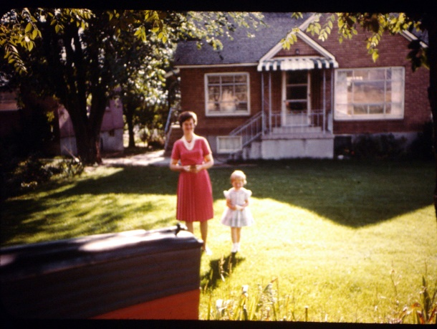**Chapter 28 – BACK TO UTAH – HOME AT 1747 N MAIN – AUG 1974 TO NOV. 1975**

In May of 1975 when I called Mom to let her know we would be moving back to Utah, she was so excited and she asked if we’d like to rent their old home in Sunset. (The home I grew up in) as it was vacant right now. We decided this would be good as then we’d have a home to come to and we could live there until we decided where we wanted to build or buy our home. It was exciting arriving in Sunset and showing the children the home and yard, the park in back of our home, etc., and sharing with them the memories I had of growing up and what I liked to do and where I would go, etc. Sometime later, I took them for walks and showed them where my friends had lived and our other good neighbors and friends.

The first Sunday when we went to church, the people were so excited to have us in the ward as they remembered us and needed us in the ward. The ward has problems. The members, it seems, just do what they have to do and sometimes not even that much. There’s not much enthusiasm or the spirit that they should have. **Sister Miskin** was the Relief Society President and she asked the Bishop right away if I could teach in the Relief Society so I was called to teach the Spiritual Living lessons. I enjoyed this calling and felt I learned a lot as the teacher always learns the most. They asked Ken to be the High Priest Group Leader. We had wonderful neighbors.

The **Thompsons** bought Grandpa and Grandma Bushnell’s home after they passed away. They remodeled the home as he was a carpenter. They were an older couple, but very wonderful people. They were always bringing us over some goodies. Around Thanksgiving they brought us over a turkey as they said they had been given three and they wanted us to have one. **Belva Provost** was Sandy’s lst year Beehive teacher in M.I.A. and a very wonderful one. In their class they picked a secret grandmother and Sandy picked Sister Thompson. She did special secret things for Sister Thompson during the year and at the end of the year, they had a special night to honor their secret grandmothers and when Sister Thompson found out that Sandy was her secret granddaughter, she made a dip and drape doll for her. It was really cute with red hair, a yellow and white plaid dress and hat and a white apron. Sandy was really thrilled and it still sets on her dresser.

Our neighbors next to the Thompsons were **Ross and Glenda Taylor**. Glenda is Melba Miskin’s daughter and Melba lived next door to them. We enjoyed Ross and Glenda. We went out to eat with them, invited them to our home for dinner, went bike riding with them, etc. Glenda and I also worked on several projects and committees for ward activities. After about the third one in a row, she told her mother that she needed a rest from them, as I always went all out and it was so much work.

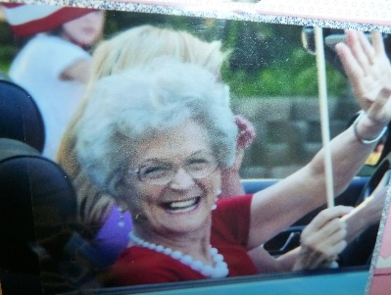 We became good friends with **Ralph & Belva Provost** and with **Ben and Linda Sisneros**. The six of us would go out to eat together and enjoy visiting. They were wonderful people. Sandy and the Sisneros’s daughter, Julie, were also good friends. The only problem with this friendship was that Ben was too strict. He would say “No” before the two children could hardly even ask him anything. Julie couldn’t play with Sandy very much when Ben was around. I guess he thought she should stay home and not play with friends. Linda was better about that and would let them play when Ben wasn’t home. Linda and I would talk on the phone for an hour or more at a time. Whenever she called, I knew I would be on the phone for quite a while, but she was really fun to talk to. She is really talented. She is an artist, in fact, she painted me a picture that I really love. She always does the roadshows because she is so good. She writes the script, paints the scenery, designs the costumes, directs the roadshow and everything else. She asked me to be in the entre act along with several other women. It was really fun. She made us a costume out of cardboard and painted them. We carried them and stuck our heads through. I was the Shirley Temple doll. **Dorothy McKnee,** (another good friend that we went square dancing with, her husband and Ben Sisneros were counselors in the Bishopric) was another doll, Belva Provost was the Raggedy Ann doll and Glenda Taylor was a little girl in it who was trying to decide which doll she wanted to buy. Linda is such a perfectionist that we had lots of practices, but I really enjoyed it.

Linda also asked Ken and I to be in a play that she was asked to direct for our wards Art Festival. I was the mother of the bride in the play. Belva is very talented in drama so she was the bride. Her son was also in it, plus Ken and Ben and two other older teenage boys who were also very good. It was a hill billy play, and we really had a ball practicing it and putting it on. I was surprised that I could do something like that as I’d never before had a main part in a play. It’s surprising what you can do if you try and ask the Lord’s help. When we had the Bushnell Reunion in May 1976, Mom asked if we could put this play on for them. The rest of the cast agreed and Linda felt it would be good experience for us and so we did.

Several years later, Ralph Provost passed away and it was hard on Belva. They were only able to have two children and Robin, their daughter, married, but he wasn’t a good husband, so she divorced him. Belva & Ralph’s son became gay. Belva would have been a wonderful grandmother, but neither of her children had children. I’m sure that is so hard on Belva. Belva moved to East Fruit Heights and became the mayor. This picture shows her in a parade as the mayor. Her daughter, Robin, is in the DUP with me now in 2017. She is a sweet lady, like her mother. She became a school teacher, but is retired now. Belva’s health reclined and she moved in with Robin and Delynn (Robin’s roommate) and she passed away several months later. Ben Sisneros passed away also leaving Linda at an early age.

**Mike, David and Scott’s bedroom used to be my bedroom**. It had a window that was over the roof of the porch of the basement outside door. Mike was 5 and David was 4. I would put them down for a nap and close the door. I must have put Scott down for a nap in our bedroom. Anyway, a couple of hours later, I would hear them call out to me and say they were awake and could they get up now. I didn’t find out until after they were married that soon after I would close the door, they would open the bedroom window, climb out onto the porch roof and slide down the column posts and run down to the park, which was just below the end of our lot. They said they would play there until they thought it had been long enough that I might check on them, so they would run home, climb up the posts, open the window and climb back into bed and then call out to me. I’m not sure how I never checked on them all that time. I’m sure glad they didn’t get hurt. Now days, if that happened they might be kidnapped, but it was much safer in those days.

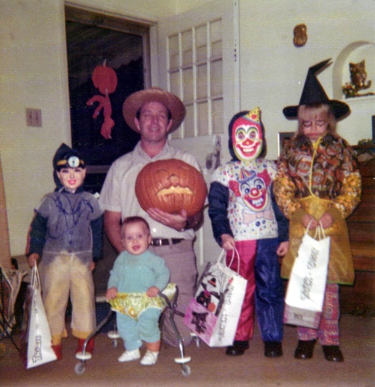 Ken and I used to give our children an allowance. They had chores to do each day, but they were expected to do those and help out as we were a family and worked together, but we knew they needed some spending money, so we gave them a weekly allowance. Mike and David have always been “best buddies”, but they are very different. One thing I will point out here is how they deal with money. David is a saver and Mike is a spender. They were this way even starting at this young age. When they would get their allowance, they would walk together over to the little store on the corner. Mike would spend all his money on candy, pop, ice cream or whatever. David would buy a few 2 for 1 penny candies and save the rest of his money. A couple of days later, Mike would want some more candy and he didn’t have any money so he would ask David if he could borrow some money from him. David knew about interest, so he told Mike he would give him so much, but he had to pay him more than he borrowed. Mike agreed, so when they got their next allowance, Mike had to pay David almost half of what he got. Mike kept borrowing practically every week, so he was always in debt to David and David kept saving his money and making more from Mike. They were both good to pay their tithing first. I remember when we were first teaching them about tithing and gave them their allowance; Mike gave us most of his money and said it was for tithing. When we discussed it with him, he had thought he got to keep 10 cents and pay the rest, instead of the other way around. He was happy to learn that he got to keep most of the money, but we thought it was neat that he had been willing to give the 90 cents.

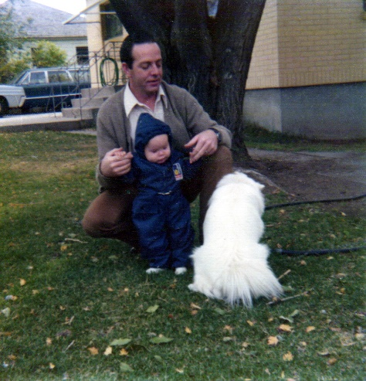We got a beautiful dog - a white Spitz, named **Casper.** Sandy wanted a dog so bad. She said she would even pay for it. She was babysitting, so earning some money. Ken didn’t want one, but he finally made some stipulations that if we could find a dog that was a female, had been spaded and had the shots, was housebroken, a good dog and good with children, a good watchdog, etc., etc. He even said if it was white and didn’t cost much money - then we could have it. I went to a lady’s home in Clearfield sometimes to get my hair done. One day when I was over there, I saw her beautiful white dog and commented on it. She said “Do you know anyone who would like her?” I asked her why and she said they loved the dog and it was such a good dog, but they lived by where the school kids passed on their way to school and the kids would tease the dog and was making her mean. She didn’t want that to happen so they had talked about giving her away to a good family who would love her and take good care of her. The dog met all of Ken’s stipulations - so I told her we would love to have her. I did offer to pay $10 because they had paid a lot of her and had her spaded, shots, etc. I can’t remember whether Sandy paid the $10 or me, but Sandy was so excited as were all of us. Ken was really surprised as he didn’t expect me to be able to find such a dog. He grew to love her too. I think the Lord had a hand in that as we did need Casper. She was a great comfort and joy to all of us. I think she was the only house dog we had as Ken felt that dogs & cats needed to stay outdoors.

**It is now July 1975 and we are on vacation at Island Park in Idaho at Buttermilk Campground**. It is so beautiful & peaceful here. We have been here almost a week. This weekend we will enjoy being with relatives for the Robinson reunion here at Mac’s lodge. **When we were setting up camp, David started calling me. I looked around and couldn’t see him. He yelled “up here Mom, I’m up in the tree”. I looked up to where the sound was coming from and there he was up at the top of a tall pine tree. He was holding onto the top and swinging back and forth. I was really frightened as he was only about 3 or 4 years old. I told him to get back down and we went over to help him after he got almost to the bottom. I don’t know how he could have climbed that tree, but David was daring and loved adventure. Soon after that, he said he needed to go to the bathroom. Shellie was riding her bike and we asked her to take him to the bathroom. Sometime later, we couldn’t find David and asked Shellie where he was. She said “I don’t know”. We found out she had taken him to the outhouse and then left him there, and continued riding her bike. We became frightened as it was starting to get dark. We all went in different directions, calling him and frantically looking for him. Finally, a man came towards us holding David’s hand. We were so relieved to find him. David said he came out and couldn’t find Shellie and started walking to find us, but he had gotten lost. He was frightened and started to cry when the man had found him. We were upset with Shellie for leaving him, but so thankful he was alright**

**GRANDMA’S RASBERRIES (MY MOM’S) (Put picture of her in her raspberry patch)**

My mother had a big raspberry patch and while we were living here in Sunset, Mom asked if the children and I could come and help her pick them. I could have what I picked and she would pay the children for what they picked, as she sold them in cases to her customers. We would go early before it got hot. We also would eat as we picked. We had a small bucket tied around our waist with a small rope. When the bucket was full, we would empty it into baskets to form a case of raspberries. Many times, I would pick mine to make jam and frozen raspberries for salads, but other times I would pick them to help mom sell them to other people. Mom would pay the children to pick them for other people. It was hard at times because the raspberries were so close together and we would get scratched, sun burned, have spiders & other insects get on you, etc. But it was also good to spend the time with Mom/Grandma and visit with her as we picked. They were delicious, big raspberries so we sure enjoyed them too. Dad picked them sometimes also.

**Ken was very discontent working for John Howard at the Commercial Security Bank’s data processing center.** John had made several promises that he didn’t keep. One, he told us that if we had any trouble selling our home with having to move so quick, that the bank would either make the payments for us, or buy it. Well, they didn’t, and we did have a hard time selling it. Everything had tightened up in Mesa and Phoenix as people were out of work and having to move (a big recession) so there were so many homes for sale and people couldn’t afford to buy a new home. Larry and Tammy offered to try to sell it for us so they ran an ad in two newspapers. Larry fixed up the yard after our other neighbor had let everything about die out. He was going to keep it up for us and then we would pay him, but I guess he was too busy so it really ran down. Larry suggested that we put up a nice fence since so many of the people who looked at the home wanted a fence. Ken and I decided to go down and build the fence. We enjoyed the visit with our friends and the nice trip, but the fence cost us $700.00 which we really couldn’t afford. Time went on and the home still hadn’t sold. We felt it was really a burden on Larry and Tammy to have to keep up the yard when they lived about five miles away, and to have to go back and forth to show people our home - so we decided to list it with a realtor even though it meant that we would lose more money because they would take out their commission. We were having a hard time financially since we were paying Mom and Dad $150.00 a month rent, and still making $200.00 a month, house payments on our home in Mesa. Ken talked to John to see if they wouldn’t make the payment or help us as he had promised. He finally got us what the interest payment would be on the home for two months, but Ken practically had to beg him for that. Time went on and we didn’t know what we were going to do. Finally, the realtor called and made an offer to buy it herself for rental property. It meant that we would really lose on the home. In fact, the little bit that we would get would pay Larry and Tammy for the money they had put into our home fixing it up and the ads in the paper and the fence. It also meant that we wouldn’t have a down payment to put on another home for us here in Utah. We were really sick because we had planned to have Ken build us a home on an acre of land. We had even looked at some land in Clinton. With this Dilemma, Mom and Dad offered to let us buy the home we were living in. They had it appraised for $37,000. That included the apartments in back. We really didn’t want the home because it was old and would need new plumbing and wiring. And the kitchen and bathroom needed to be remodeled, and Ken had wanted a garage which this home didn’t have. But, we didn’t have a down payment and the folks would let us buy it for nothing down and a lower interest that we could get on any other home, so we had about decided to buy it. Then Ken said one evening, “I just don’t want this home.” So, I said that we shouldn’t buy it then. Mom and Dad were disappointed because they wanted us to buy it for sentimental reasons and also that meant that we would be living close to them.

Ken confronted John with breaking this promise and also several others. One was that Ken would only have to be the data processing supervisor on graveyard shift for a few months or a year and then he could move into the daytime programmer’s department. Ken couldn’t sleep very well during the day and it seemed to disrupt the whole family with his unusual schedule. I was always fixing meals it seemed. I would fix breakfast for the children, then Ken would come home from work and I’d fix breakfast for him. Then lunch for us, then Ken would wake up and I’d fix him lunch. We’d be hungry for supper and he wouldn’t. So, we would stagger that or try to compromise. It was hard on my nerves trying to keep the children quiet while he slept. He couldn’t sleep very well, so he was cross a lot of the time. Not only from not getting enough sleep, but because he was unhappy at John.

Irven, Ken’s younger brother, was working for Burrows company in Salt Lake and talked to **Gary Miles who owned a programming company** and did work for the Burrows company, about Ken. He had Ken come down for an interview. It went very well, and he said he’d let us know. On returning from our vacation at Island Park in Idaho, we found a message that Gary had called and wanted Ken to return his call. Ken did and got the job. We were really thrilled. Ken commuted back and forth every day. This soon got tiresome as it was expensive for gas and it took away two extra hours from the family.

In July, just prior to our leaving for vacation to Island Park, **Bishop Sid Sly** came to our home to talk with me. He said they were changing the primary presidency as Sister Holbrook had been in for several years. He asked if I would be the new **primary president**. I told him that Ken had changed jobs and was working in Salt Lake now and we would probably be moving down to Salt Lake in the near future. He said he felt inspired to call me and that they would like me to hold that position as long as I did live here. I consented. While on our vacation I prayed and tried to decide on my counselors. When I returned, I talked to Ben Sisneros about my choices and he helped me decide. (He was the counselor over the primary). I chose **Karen Bidwell as my first counselor and Kay Kendall as my second counselor**. Our secretary was sister Fern Beesley. We visited our teachers and decided on some others for classes without teachers. We decided to make cakes for the teacher’s birthdays and do some other projects. We held our presidency meetings the morning before primary. I grew to love these two counselors and I enjoyed working with them and the teachers. We bought our home in August, but had to wait until the last of October to have it approved and the paper work done. We moved the last of November. My special counselors and secretary bought me a darling **little ceramic doll. It has a green dress with pink flowers**. I have it still today and cherish it. I have gotten many gifts from special friends, neighbors and those I served with in the church and I keep them around my home to remind me of these special people and they bring back special memories.

When the Bishop told **Sister Miskin** that I would be released from the Relief Society to be President of the Primary, she was very upset. In fact, the Sunday that I was sustained, she walked out of Sacrament Meeting at that time. She told me afterwards that she felt that anyone could be president of the primary, but only certain ones could be good teachers in the Relief Society. She said she told the Bishop that he might as well release her if he was going to release me as I was one of the main ones that kept the Relief Society going. I don’t feel this way. We are all replaceable. It was just that I enjoyed this position and I tried to do my best as I try to in any position that I hold. I know that if I do all I can, the Lord will bless me and help me to magnify my callings. I love the Lord and love serving him and his children. I had made posters and other visual aids and handouts and I tried different methods such as panel discussions, handed parts out or assigned things to other sisters and I did put a lot of time into my lessons, which I guess some of the other teachers did not. But, Sister Miskin was overly dramatic about it. I felt bad that she was resentful towards the Bishopric for this change as there is always change and we have to trust in the Lord that it is what he wants.

I was also the Sunday School Librarian in the Sunset 2nd ward. I enjoyed the ward and my friends and associations there. Judy Gebheim was in the Relief Society Presidency and also P.T.A. President. Judy and I have been good friends ever since she and Hendrick (Ken’s best friend growing up) were married. When Hendrick was killed in a truck accident, she married Dennis Gebheim a year later. He isn’t a very good husband or father, but Judy still stays with him. They moved to Sunset so I was glad to be reunited with her. She asked me to be the Safety Chairman in the P.T.A. President Petersen of our Stake Presidency was the principal of the elementary school. I enjoyed this position although it was a lot of work and took a lot of time. One of my responsibilities was to carry out Safety Week. We had contests, showed films, had bike safety courses and I gave the teachers several suggestions to do during that week.

When I was released as Primary President, prior to our moving, they put in Karen Bidwell, my lst counselor as the president. Her husband wasn’t very active, but he supported her. Karen is a bubbly talkative person. We’d usually be on the phone for long periods of time when I’d talk to her, but I enjoyed it. Karen was also my Relief Society visiting teaching partner. She wasn’t afraid to go the extra mile either which also made me want her for my counselor. Soon after we moved to Taylorsville, the Sunset 2nd ward bishopric was changed. The new bishop was Mel Wood. He called and asked our family to come and speak in the ward. We did so and were happy to see everyone again. Whenever we go back to a former ward, the members always treat us so good and act so happy to see us. We’re thankful for these people and the things we have learned from them and the experiences we have had. When we moved, the Sunset Stake President, President Rock told us, when we saw him at a wedding reception, that we weren’t supposed to move because **they had Ken in mind for the new bishop**. Also, President Peterson had told me that, when I was at the elementary school. Other members of the ward also expressed that same thought. I feel Ken would have been a bishop by now if we hadn’t moved so many times. He probably would have been in the Mount Fort Ward because our stake president there, Pres. Wimmer had told us about that same thing when we were moving from there. He could have been in Clearfield also because he was serving as lst counselor when we moved to Mesa. When Bishop Rees was released and Bishop Opie was put in as Bishop of the Lehi 3rd ward in Mesa, we were talking with him at his daughter’s wedding breakfast in Salt Lake and he said he surely would have asked for Ken to be his counselor had he still been in the ward, and that he had a hard time choosing his counselors. Ken feels that the Lord probably knows that he shouldn’t be a bishop and that’s one reason why we keep moving. I don’t feel that way; I feel Ken would make a wonderful bishop. He says he doesn’t have enough patience with the members, but then maybe he would learn more patience. Although, it’s fine with me if he isn’t called to be a Bishop as it is a very demanding position and it would be hard on Ken, me and the family (although I know the Lord blesses you also). Ken is a very wonderful and spiritual person and whether or not he ever becomes a bishop, I feel he is worthy and I’m sure thankful for him and for the example he sets for me and our family.

We had lived in Arizona for three years before moving back to Utah. While living in Sunset, **David had another problem with his health.** He again didn't have much energy so I called Dr. Swanstrom as I wondered if David was low on iron again. It is interesting that we have had David's blood tested by other doctors and they say his blood is normal. We know better because he isn't healthy and when we send a spernum (I think that's what Dr. Swanstrom called it - the test by saliva) Dr. Swanstrom would say he was low and would send more iron and magnesium up and he would get well again. This time Dr. Swanstrom told me that David had a film growing over his white cells and he would send hydrochloric acid up and to follow his directions carefully. I asked him what the problem was and he said that David could literally starve to death - that with this film over his white cells, he couldn't assimilate the food. He could eat wonderful food, but it wouldn't do him any good. I was worried and Dr. Swanstrom said he felt this would dissolve the film and he would be ok. He did tell me to send a spernum from David just shortly before we finished giving him all of it. It came in a bottle with a dropper. We were to put so many drops of it into half a glass of water each day. Dr. Swamstrom told us the seriousness of it as people had died of this. He said the spernum would tell whether the film was dissolved and if it wasn't, he would send up another bottle, but all he could have David take was two bottles. If that didn't work, he didn't know what else to do. We sent the first spernum down and it hadn't dissolved the film so Dr. Swanstrom sent the 2nd bottle up. I prayed constantly that this 2nd bottle of hydrochloric acid would dissolve it. When we sent the next spernum down, he called and said it was dissolved and David should be fine. Boy, were we ever grateful to him and the Lord.

We lived in Sunset two years and then moved to Taylorsville